# Tip Sheet: How to Document Medication Samples

____________________________________________________________________________________

If you provide medication samples to your patients, you will need to document this in Epic. You can be in a telephone encounter or an office visit.

Telephone Encounter:

1. From the telephone encounter tool bar select **meds & orders**



1. Enter the medication, bottom left corner.



1. Fill in the necessary fields. Do not send prescriptions, select **Sample** and click accept.

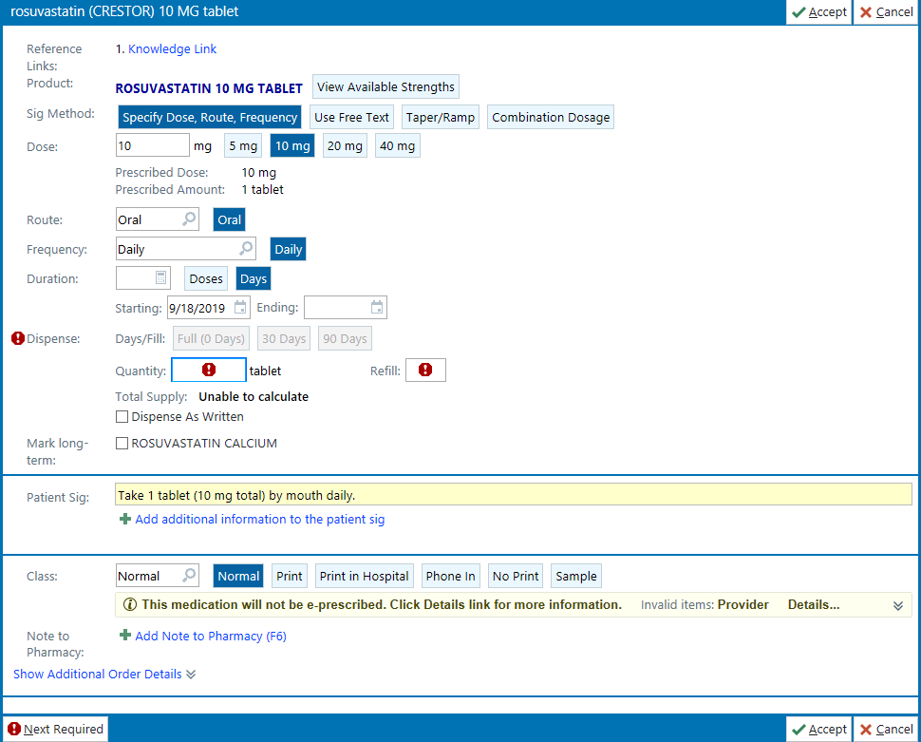

1. Pend the order for provider’s signature

Office Visit Encounter:

1. You can be anywhere in this encounter, use the Add order filed on the bottom left corner



1. Follow steps 3 and 4 from above.